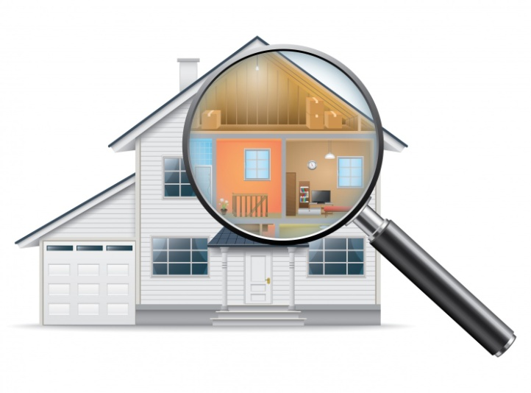
COMPLETE YOUR OWN INSPECTION

Please use this guide to complete your own home inspection prior to your home evaluation appointment. The following information is a summary of the Directives provided by California Department of Social Services.
Article 11

___ Section 11-011 (a) (1): (1) The home shall be clean, safe, sanitary, and in good repair

KITCHEN AREA:
___ Section 11-03 (a): Except as specified in subsections (c) and (d), a Resource Family shall store medicines, disinfectants and cleaning solutions where they are inaccessible to a child or nonminor dependent.
___ Section 11-03 (f): A Resource Family shall store and dispose of waste in a manner that will not permit the transmission of communicable disease or odors, create a nuisance, or provide a breeding place or food source for insects or rodents.
___ Section 11-01 (a) (4) (B): Faucets to be used by a child or nonminor dependent for personal care and grooming shall deliver hot water at a safe temperature.
___ Section 11-03 (b): A Resource Family shall store poisons, firearms, and other dangerous items or weapons in a locked storage area.
___ Section 11-03 (c): A Resource Family shall apply the reasonable and prudent parent standard, as specified in Section 11-12, in determining if it is age or developmentally appropriate for a child to have access to and use the following items:
- (1) Household kitchen knives and appliances for use in meal preparation.
- (2) Medications necessary for self-administration by the child.
- (3) Disinfectants and cleaning solutions for use in performing household chores.

LIVING ROOM AND DINNING ROOM:
__ Section (a) (7): There shall be lighting as necessary in all rooms and other areas of the home and grounds to ensure comfort and safety.
__ Section (a) (6): A safe and comfortable temperature shall be maintained in the home.
___ Section 11-01 (a) (5): Fireplaces, open-faced heaters, or woodstoves shall be maintained to ensure safe operation.

BATHROOM AREAS:
___ Section (a) (4): At least one toilet, sink, and tub or shower shall be maintained in a safe, clean, and operating condition. (NO BROKEN OR CRACKED MIRRORS OR GLASS DOORS. )(a) (4) (A): Bathrooms shall be located inside the home.
___ Section 11-03 (a): Except as specified in subsections (c) and (d), a Resource Family shall store medicines, disinfectants and cleaning solutions where they are inaccessible to a child or nonminor dependent.
(Bathroom areas CONTINUED…)

___ Section 11-01 (a) (4) (B): Faucets to be used by a child or nonminor dependent for personal care and grooming shall deliver hot water at a safe temperature.
___ Section 11-03 (b): A Resource Family shall store poisons, firearms, and other dangerous items or weapons in a locked storage area.

BEDROOMS:
__ Section (a) (7): There shall be lighting as necessary in all rooms and other areas of the home and grounds to ensure comfort and safety.
___ Section (a) (8) (A) and (a) (8) (B) i through ii: Bedroom arrangement requirements:
- No more than four children per bedroom.
- The Resource Family and County shall document bedroom arrangements, ensure health and safety of each child, and determine compatibility of each child.
- Bedroom arrangements and compatibility will be determined based on the , child(ren)’s age, wishes, privacy needs, sexual orientation, developmental levels, history of sleeping arrangements, history or suspicion of sexual abuse or exploitation.
___ Section 11-01 (a) (8) (E): In bedrooms shared by a Resource Family and infant, no more than two infants shall share the room.
___ Section 11-01 (a) (8)(F): Children of different sexes may share a bedroom under the following circumstances:
- (i) Each child is under eight years of age.
- (ii) A minor parent may share a bedroom with his or her child.
- (iii) A Resource Family may permit a child to share a bedroom consistent with the child’s gender identity regardless of the gender or sex listed on his or her court or child welfare documents.
___ Section 11-01 (a) (8) (J): (J) Each bedroom shall have at least one operable window or door that ensures a safe, direct, emergency exit to the outside. (NO BROKEN OR CRACKED WINDOW PANES.)
___ Section 11-01 (a) (8) (K): Each child or nonminor dependent shall be provided with an individual bed, which is equipped with a clean and comfortable mattress, clean linens, blankets, and pillows, as needed, all in good repair
___ Section 11-01 (a) (8)(L): Bunk beds of more than two tiers may not be used. (i) Bunk beds shall have railings on both sides of the upper tier to prevent falling. (ii) A child under six years of age or who is unable to climb into or out of the upper tier unassisted may not be permitted to use the upper tier.
___ Section 11-01 (a) (8) (M): Each infant, or child requiring a crib, shall be provided with a safe and sturdy bassinet or crib as appropriate to the age and size of the infant or child. The following shall apply to cribs.
___ Section 11-01 (a) (8)(N): Each bedroom shall have portable or permanent closets and drawer space to accommodate a child's or nonminor dependent’s clothing and personal belongings.
___ Section 11-01 (b): A Resource Family who intends to accept a child or nonminor dependent with a developmental, mental, or physical disability shall make necessary modifications to the RESOURCE FAMILY APPROVAL PROGRAM PAGE 63 VERSION 4.1 EFFECTIVE DATE: 06/09/2017 (Revision Date: 05/09/2017) home and grounds to provide protection and assistance and to maximize the potential of a child or nonminor dependent for self-sufficiency.

HALLWAYS:
___ Section (a) (1): Except for a home with a sprinkler system, a home shall have an approved, commercially manufactured, and functioning carbon monoxide detector and smoke alarm or smoke detector installed in the hallway of each sleeping area in the home. A detector and alarm shall be audible in each bedroom.

OUTDOOR AREAS:
___ Section (a) (3): All outdoor and indoor passageways, stairways, inclines, ramps, and open porches in and on the grounds of the home shall be free of obstruction.
___ Section 11-02 (a) (1): A yard or outdoor activity space shall be free from hazards that endanger the health and safety of a child or a nonminor dependent.

MISCELANEOUS:
__ Section (a) (6): A safe and comfortable temperature shall be maintained in the home.
___ Section 11-01 (c): A Resource Family may not smoke or permit any other person to smoke inside the home, and, when a child or nonminor dependent is present, on the outdoor grounds of the home.
___ Section 11-02 (b): A Resource Family shall ensure that swimming pools, fixed-in-place wading pools, hot tubs, spas, or similar bodies of water are inaccessible if he or she accepts placement of any of the following individuals:
- (1) A child under ten years of age.
- (2) A child who is developmentally, mentally, or physically disabled.
- (3) A nonminor dependent who is developmentally, mentally, or physically disabled.
- (4) A minor or nonminor dependent parent’s child who is under ten years of age or developmentally, mentally, or physically disabled
___ Section 11-02 (a) – (e): A Resource Family shall ensure the inaccessibility of swimming pools, fixed in-place wading pools, hot tubs, spas, or similar bodies of water by using at least one of the safety features described in paragraphs (1) or (2). Fence or window and door alarms must be installed. Consult your worker for more details regarding safety measure for bodies of water.

___ Section 11-03 (b): A Resource Family shall store poisons, firearms, and other dangerous items or weapons in a locked storage area.
- (1) In lieu of locked storage of firearms, a Resource Family may use trigger locks or remove the firing pin.
- (2) Ammunition and firing pins shall be stored and locked separately from firearms.
___ Section 11-05 (a): A Resource Family shall place emergency telephone numbers in a prominent location in the home.
___ Section 11-07 (a): A Resource Family shall maintain separate, complete, and current records in the home for a child. Designate a secure area to store child(ren)’s confidential documents.
___ Section 11-09 (a): A Resource Family shall have cellular telephone, Internet telephone, or landline telephone service in the home at all times. (b) Telephone service shall be accessible to a child or nonminor dependent in the home at all times.

